Chua, Kyle Rendell

2 ECE - E

Problem number 1

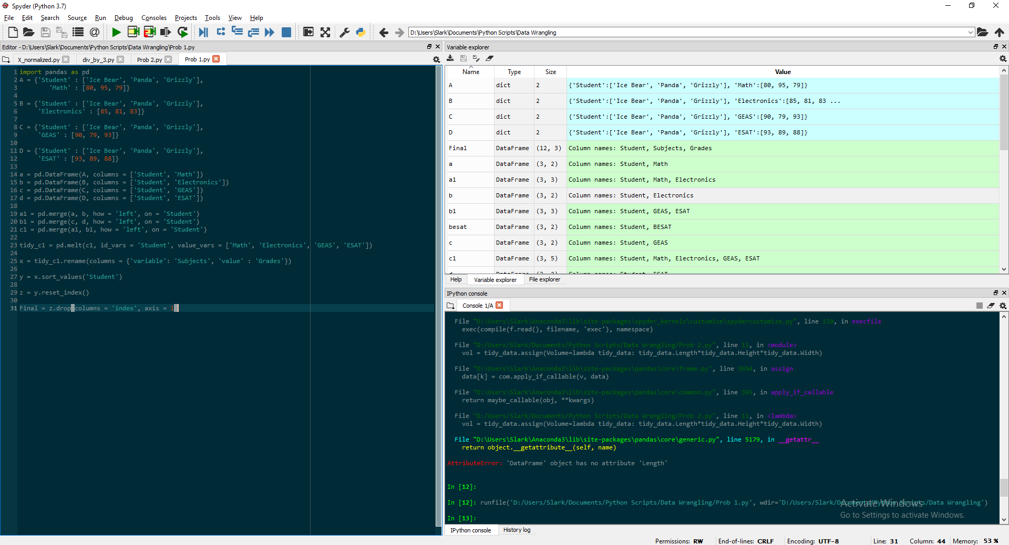

Problem number 2